“How Might Our Actions Be Affecting Our Earth?”

The Reality of the Rainforest

Understanding and Anaylsis

of the Importance Earth’s Environments

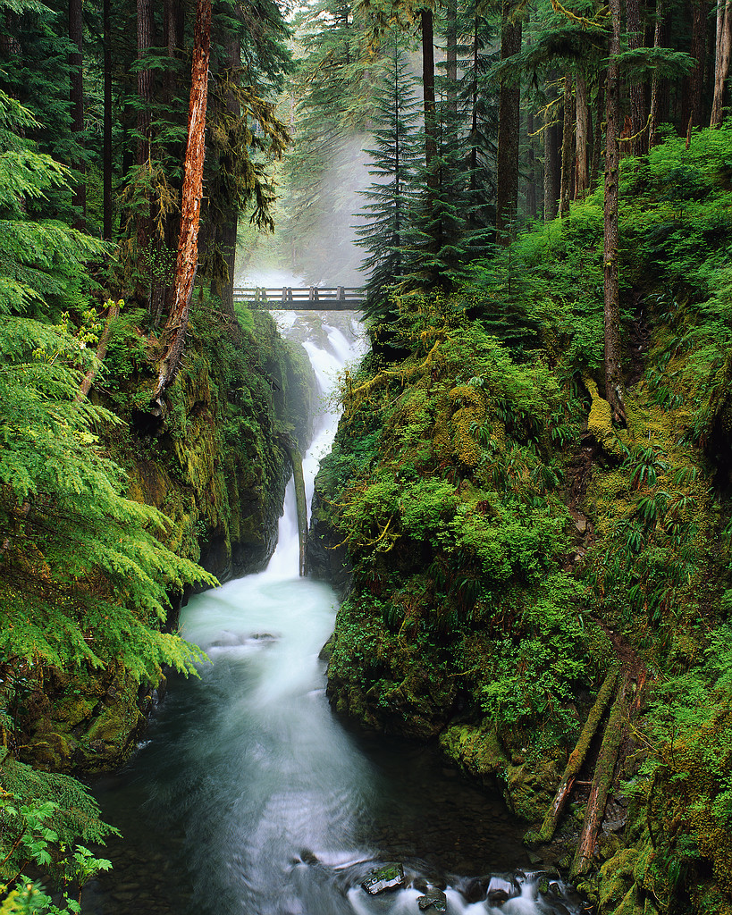

A Technology Integration Learning Plan for Fourth Grade

Developed by Krissy Venosdale
for ED7377
September 15, 2007

Project Overview:
This project is designed to take place over a two-week period. Students in this project will be designing a video about the affects of the deterioration of the rainforest on us and what we can do to help. Throughout the project, students will use Moodle, an online classroom environment, to collaborate with students in another state or country who are also working on the project. At the end of the project, students will be sharing their videos with the other class and viewing what they have created as well. This project will demonstrate that the deterioration of the rainforest affects our entire planet in much the same way!

Table of Contents
Analysis: 3
Design and Development 4
Desired Outcomes: 4
Resources & Media: 5
Learning Activity Structure and Sequence: 6
Assessment: 6
Implementation: 7
Evaluation 8

Analysis:
To determine the needs of my students, I will use three methods: Small Group Questioning, Individual Pre-Test, Technology Needs Assessment of the topics that will be covered.

The Small Group Questioning Assignment will be done with the entire class providing questions under the essential question “How might humans effect the earth?” Students will brainstorm and all questions will be placed on the SMARTBoard. Following this discussion, the file will be made available to students at their personal workstations. Small groups of students will categorize questions and organize our needs for research. This assessment will guide me in what students already know as well as what they are interested in.

Individual Assessment: Students will take an online teacher-created quiz and will be a quick way for me as a teacher to know what level of knowledge students currently have on the objectives that will be covered in this project. The following questions will be asked in the assessment:

-What is a predator?

-What is a food chain?

-What is a food web?

-What is a consumer?

-What is a producer?

-What is supply?

-What is demand?

-Is the rainforest important to us in Missouri?

-Is it okay to use words from a website and not list where they came from?

Technology Needs Assessment: Prior to this lesson, I will assess the needs of my students in the use of Windows Movie Maker and identify strong anchor students to be in each of the groups created for the project.

Design and Development
Desired Outcomes: The lesson will focus on the following objectives from the Missouri Department of Elementary and Secondary Education Grade Level Expectations (DESE GLE’s) available at: http://dese.mo.gov/divimprove/curriculum/GLE/GLEindex.html

Communication Arts
Non Fiction Reading
Use details from text to retell main ideas, identify cause and effect, draw conclusions, compare and contrast texts, make predictions, make inferences, distinguish between fact and opinion, identify and explain author's purpose, make inferences about problems and solutions
Writing for Audience and Purpose
Write informational reports, diary/journal entries, organized friendly letters, thank-you letters and invitations in a format appropriate to an intended audience and purpose
Discussion and Presentations:
In discussions and presentations,present ideas in a logical sequence and identify and apply appropriate speaking techniques such as volume control, pace and eye contact
Researching
- Formulate and research keywords and questions to establish a focus and purpose for inquiry
- Locate and use various resources to find information on keywords and questions
- Identify relevant information and record main ideas and important details in own words
- Informally give credit for others’ ideas, images and information found in various resources

Science
Interactions among Organisms and their Environment
- Identify the ways a specific organism may interact with other organisms or with the environment (e.g., pollination, shelter, seed dispersal, camouflage, migration, hibernation, defensive mechanism)
- Recognize different environments (i.e., pond, forest, prairie) support the life of different types of plants and animals
- Classify populations of organisms as producers, consumers, or decomposers by the role they serve in the ecosystem
- Differentiate between the three types of consumers (herbivore, carnivore, omnivore)
- Categorize organisms as predator or prey in a given ecosystem
- Identify the ways humans affect the erosion and deposition of Earth’s materials (e.g., clearing of land, planting vegetation, paving land, construction of new buildings)
- Propose ways to solve simple environmental problems (e.g., recycling, composting, ways to decrease soil erosion) that result from human activity

Social Studies
Knowledge of Economic Concepts
- Explain supply and demand
- Interpret past, explain present and predict future consequences of economic decisions. (Decisions would be of a nature that is meaningful to fourth graders, such as decisions made by consumers and decisions pertaining to the environment)
- Describe how people are affected by, depend on, adapt to and change their environments
Knowledge and Use of Tools of Social Science Inquiry
- Construct and Interpret Maps
- Identify, select and use visual, graphic and auditory aids
- Use and evaluate primary and secondary sources (diaries, letters, people, interviews, journals and photos)
- Identify and use library and media resources (electronic resources, dictionaries, encyclopedias, videos, periodicals, atlases, almanacs, telephone directories, books, and cartoons)
- Identify and create artifacts (building structures and materials, works of art representative of cultures, fossils, pottery, tools, clothing, musical instruments)

Resources & Media:
- Moodle online classroom environment: availble for free at http://www.moodle.org

- Hot Potatoes Assessment Software from http://hotpot.uvic.ca/

- SMART Notebook software for dragging and arranging questions; Available from http://smarttech.com/

- Free Music for videos at http://www.freeplaymusic.com/

- Audacity Voice and Music Recording Software free at http://audacity.sourceforge.net/

- Windows Movie Maker Software available on any computer with Windows XP.

- Websites for Internet Research from eTHEMES search tool: http://www.emints.org/ethemes/resources/S00000684.shtml

- Hardware Necessary: Computer with Wndows XP, Microphone, Speakers, and SMARTBoard or (TV with DVD) for presentation.

- The Rainforest Habitat: a video from www.unitedstreaming.com available with a school subscription that shows what lives in the rainforest and what life is like there

- Life Science Ecology: a video from www.unitedstreaming.com available with a school subscription that show students exactly what one event can do to affect another in an ecosystem.

Learning Activity Structure and Sequence:

- At least one month prior to the project: Contact another teacher (from another school or state) to collaborate with. Set up the project in a similar time frame so that projects can be shared online with other classes through the use of Moodle, an online classroom environment. Begin taking note of students showing strength in the use of Windows Movie Maker; Work on identifying anchor students for the small groups.

- Day 1: Questions and Pre-Test; Organize questions in small groups to develop learning focus throughout the project. (1.5 hours)

- Day 2: Read the “Great Kapok Tree” during Reading class; Begin Internet Research; Review a teacher-selected site together to practice note-taking, navigating, and set up “Rainforest Researcher Notebook” (2.5 hours Reading/Science/Social Studies)

- Day 3-5: Internet Research & Moodle Collaboration (Collection of photos and artifacts for movie will occur during research) (2.5 hours) Internet Research and Informal Teacher Interviews and review of notebook. Start Storyboarding movies (2.0 hours)

- Day 6-7: Work on Storyboards; identifying music, pictures and all media involved in movie. Students will write this information on their storyboard. As students finish, they will begin seeking “Storyboard Approval” from teacher. (2.0 hours)

- Day 8: Begin to use Windows Movie Maker; This process will be fairly quick with approval of the storyboard. Students already know the content, order, and layout of their video and simply need to put it all together. (2.0 hours)

- Day 9: Finish videos and upload to Moodle (2.0 hours)

- Day 10: Class presentations and receive videos from another school in another state; Compare other student videos with ours. (2.0 hours) Complete Post-Test; Rainforest Celebration; invite parents; display movies; and celebrate a job well done! Eat rainforest foods.

Assessment:
Rubric for Movie Maker Video
Pre-Test
Post-Test

Implementation:
Do students know how to use Moodle?
The project will be further enhanced if students can collaborate their research in a central location, such as through a Wiki in Moodle. Additionally, the project can be shared and collaborated at a distance with tstudents in another school or state with Moodle. Students will need to be comfortable with various aspects of Moodle (forums, file uploading, and file downloading) prior to the project.

Are students comfortable with internet research?
The research portion of this TILP may take more amount of time if students have not completed assignments requiring internet research prior to this project. Students may have difficulty with taking notes in own words and navigating sites, depending on their comfort level.

Do students already know how to use Windows Movie Maker?
Students should be comfortable with using Movie Maker and doing the following activities BEFORE attempting this project:
-Storyboarding
-Adding Transitions
-Downloading music from
-Adding Title Slides
-Adding music and voiceovers
-Using a digital scanner to add photographs or drawings

Are there going to be any interruptions in this project?
This project will require a great deal of time and assemblies, fire drill practices, and even classroom visitors will cause a need for adjusting the schedule.

Can you schedule meetings with the groups?
Meeting with each group for a few minutes at various points in the project will be necessary to guide and observe their progress.

Is there additional time available for students to work?
Some groups may need additional time to gather information and develop their video. Time could be built in to allow students to work on the computer during a daily classroom study time, a working fun-lunch, or even allowing students to stay in from recess to work if they choose to. Time should be made to allow all students to complete the assignment in the amount that they need.

Evaluation
Rubric for Movie Maker Video
Rainforest Research Notebook
Pre-Test
Post-Test
Reflection

