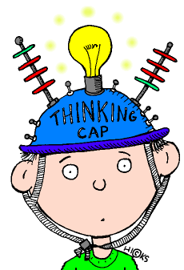
A. Focus is on specific facts, definitions,
details, or using routine procedures (measure, divide, follow recipe, etc.) B. Explaining “that…” C. Can be “difficult” without requiring “deep” content knowledge to respond to item (memorize a complex theory without being able to explain its meaning or apply it to a real work situation)
D. Combination of level ones does NOT = level 2.
E. One right answer
A. Focus is on applying skills and concepts (in a familiar/typical situation), relationships (compare, cause-effect), main ideas. B. Requires deeper knowledge than definition
C. Explaining how or why D. Making decisions E. Estimating, interpreting in order to respond F. One right answer
(Depth of Knowledge)
DOK
A. Focus is on reasoning & planning in order to respond (e.g., write an essay, apply in new/novel situation). B.Complex and abstract thinking is required. C. Often need to provide support for reasoning or conclusions drawn. D. More than one “correct” response or approach is often possible.
Level 1: Recall
Strategic Reasoning
Level 3:
Level 4:
"He who learns but does not think, is lost!
He who thinks but does not learn
is in great danger." Confucius
Extended Reasoning
Skill/Concept
Level 2:
A. Requires complex reasoning, planning, and thinking (generally over extended periods of time) for the investigation. B. Assessment activities have multiple steps with extended time provided. C. Students may be asked to relate concepts within the content area and among other content areas. D.Students make real-world applications in new situations.
Whoa
Modified with permission from a Pam Lowe poster by Debbie Perkins Clip art from Discovery School's Clip Art Gallery- created by Mark A. Hicks, illustrator.

